Sales Summary
Path : Reports >> Sales Summary
Steps to reach Sales Summary:
Step 1 : Reports in Steps to reach Sales Summary : Open the Reports module from the Billing Application(POS).
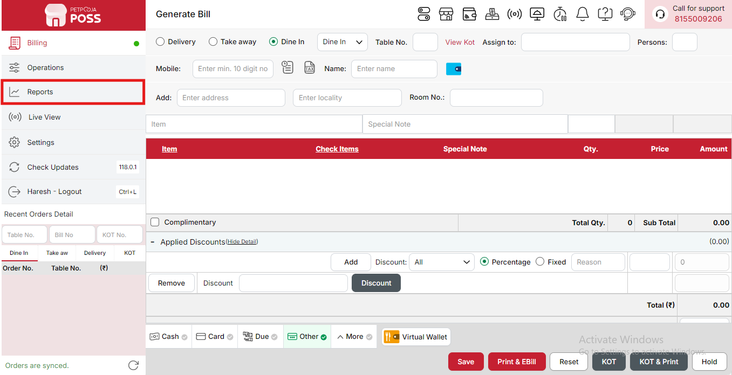
{Image Name: Reports Option,
Description: The red box highlights the “Reports” option in the sidebar menu. This section allows users to view and analyze various business reports, such as sales, billing, and order summaries, helping in effective tracking and decision-making.Here is an image of Step 1 Report in Steps to Reach Sales Summary.}
Step 2 : Sales Summary in Steps to reach Sales Summary : Select Sales Summary to view an overview of total sales, including item-wise and category-wise performance, revenue, and discounts applied.
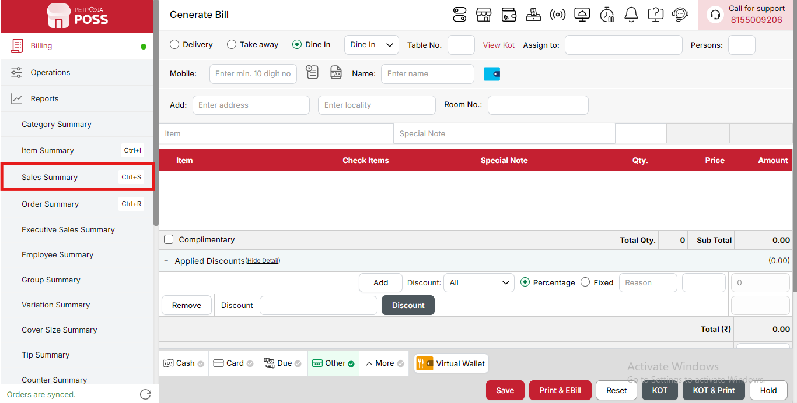
{Image Name: Sales Summary,
Description: The red box highlights the “Sales Summary” option under the Reports section. This feature provides a comprehensive overview of daily, weekly, or monthly sales data, helping users monitor total revenue, transaction count, and sales performance efficiently.Here is an image of Step 2 Sales Summary in Steps to Reach Sales Summary.}

Key features of Sales Summary :
There is Two Option To Sales Report :

Custom Report (Sales Summary) :

(Custom Report) Sales Report - [Date] :
Displays the report for the selected date or period. It summarizes all transactions and their details for that specific day. This helps management track daily sales and monitor performance trends.

(Custom Report) Order No. :
Shows the unique identification number for each order generated in the system. It ensures that every bill can be easily located for reference or audit purposes. This number helps in maintaining accurate order history.

(Custom Report) Date:
Indicates the exact date when the order was created or billed. It helps in filtering and organizing sales by day for better analysis. This field ensures accurate time-based reporting.

(Custom Report) Payment Type:
Shows the method of payment used for the order, such as Cash, Card, or Online. It helps in understanding customer payment preferences. This is also useful for reconciling cash and digital transactions.

(Custom Report) Order Type:
Specifies where the order originated — for example, Dine In, Takeaway, or Delivery. It helps analyze which order channels generate more revenue. This information supports better operational and staffing decisions.

(Custom Report) Area Type:
Displays the physical or operational area where the order was managed, such as Kiosk Test or Main Area. It helps in identifying which section contributes most to sales. Useful for branch-level or section-wise performance tracking.

(Custom Report) My Amount (₹):
Shows the total value of the order before applying any taxes or additional charges. It represents the base sales revenue. This helps in evaluating gross sales before deductions or add-ons.

(Custom Report) Discount (₹):
Indicates any price reduction or offer applied to the order. Discounts may be promotional or manual, depending on business rules. It helps assess the impact of discounts on overall profitability.

(Custom Report) Delivery Charge (₹):
Shows the fee charged for delivering the order to the customer. It helps offset delivery costs and maintain profit margins. This field applies only to online or delivery orders.

(Custom Report) Container Charge (₹):
Represents the additional charge for packaging materials like boxes, bottles, or containers. It ensures packaging costs are covered. This charge is common in takeaway and delivery services.

(Custom Report) Service Charge (₹):
Displays the service charge added to the bill, often used in dine-in settings. It compensates staff for service provided to customers. This helps in transparent billing and compliance with service policies.

(Custom Report) Additional Charge (₹):
Shows any other extra fees applied to the bill, such as special add-ons or custom requests. It covers charges outside standard categories. Useful for capturing all revenue components accurately.

(Custom Report) CGST @2.5 (A) (₹):
Indicates the Central Goods and Services Tax applied at a 2.5% rate. The “A” stands for Active, meaning this tax is currently in effect. It ensures proper tax compliance and reporting for central tax authorities.

(Custom Report) SGST @2.5 (A) (₹):
Displays the State Goods and Services Tax applied at a 2.5% rate. Like CGST, “A” indicates that the tax is Active. Together, CGST and SGST make up the total GST applied to the bill.

(Custom Report) Waived Off (₹):
Shows the amount that was canceled or removed from the order total. This might occur due to manual adjustments, refunds, or management decisions. It helps maintain transparency in billing corrections.

(Custom Report) Total (₹):
Represents the total amount of the order after discounts and charges, but before any tip is added. It reflects the customer’s payable bill at checkout. This amount forms the basis for financial summaries.

(Custom Report) Assign To:
Displays the name of the staff member or delivery person responsible for fulfilling the order. It helps in tracking accountability and performance. Useful for evaluating employee productivity.

(Custom Report) Biller Name:
Shows the staff member who created or finalized the bill in the system. This helps identify who processed the transaction. It supports audit trails and staff performance tracking.

(Custom Report) Reason:
Explains why an order was adjusted, canceled, or modified. Common reasons include customer requests or billing errors. It ensures all changes are properly documented for review.

(Custom Report) Tip (₹):
Shows the gratuity amount provided by the customer, if any. It reflects customer satisfaction and service appreciation. Tips are often distributed among service staff.

(Custom Report) Total + Tip (₹):
Displays the final payable amount, including any tip added to the bill. This shows the complete value of the transaction. It represents the true revenue received per order.

(Custom Report) Note Section:
If the bill is settled, the Settlement Amount is considered the final total amount. This ensures accuracy between recorded and received payments. It confirms the transaction has been completed.
(Custom Report) Current Status of Tax:
A → Active: The tax is currently applied and in effect.
I → Inactive: The tax is temporarily disabled or not applicable for the transaction.

(Custom Report) Columns :
Used to show or hide specific columns in the report. You can check an option to display it or uncheck it to hide it based on your reporting needs.
- (Columns) Date: Shows the date when each order was created or billed. You can check this to include order dates in your report or uncheck it to hide them.
- (Columns) Payment Type: Displays the payment method used for each order, such as Cash, Card, or Online. Check this to view payment details or uncheck to simplify the report.
- (Columns) Order Type: Shows where the order was placed — for example, Dine In, Takeaway, or Delivery. You can include this to analyze sales by order channel.
- (Columns) Area Type: Displays the area or section where the order was handled, such as Kiosk Test or Main Area. Check this to monitor performance by area.
- (Columns) My Amount (₹): Shows the total base amount earned from each order before tax and charges. You can check this to see gross revenue per order.
- (Columns) Discount (₹): Displays any discount applied to an order. Check this column to track promotional or manual discounts given to customers.
- (Columns) Delivery Charge (₹): Shows the delivery fee added to applicable orders. You can include this column to monitor additional income from delivery services.
- (Columns) Container Charge (₹): Displays the packaging or container fee for takeout and delivery orders. Check this to keep track of packaging cost recovery.
- (Columns) Service Charge (₹): Shows the service charge applied to dine-in bills. You can include this to view extra service-based income.
- (Columns) Additional Charge (₹): Displays any extra charges like add-ons or special fees. Check this to see all supplementary charges in the report.
- (Columns) CGST @2.5 (A) (₹): Shows the Central GST applied at 2.5%. You can include this to verify active central tax amounts in your sales.
- (Columns) SGST @2.5 (A) (₹): Displays the State GST applied at 2.5%. Check this column to confirm correct state tax calculations.
- (Columns) Waived Off (₹): Shows any amount that was removed or canceled from the bill. You can include this to track adjustments or refunds.
- (Columns) Total (₹): Displays the total payable amount of each order before tips. Check this to view the complete billed amount per order.
- (Columns) Assign To: Shows the staff member or delivery person assigned to the order. You can include this to track responsibility and performance.
- (Columns) Biller Name: Displays the name of the staff member who created or processed the bill. Check this to identify who handled each transaction.
- (Columns) Reason: Shows the explanation for any order modification, cancellation, or adjustment. You can include this to understand billing changes.
- (Columns) Tip (₹): Displays the tip amount given by the customer. Check this to view gratuity earnings across orders.
- (Columns) Total + Tip (₹): Shows the final amount including any tip added to the order. You can include this to see total customer payments received.
(Custom Report) Export Excel: If you want to download or save the report in Excel format, you have to click on the Export Excel button. This will create an Excel file of the report that you can open and use in Microsoft Excel.
(Custom Report) Print Button: The Print Button is used to print the report. If you want to take a printout of the report, you just need to click on the Print button.
If you get an error saying “Please assign one printer for report print”, then follow these steps:
- Go to Operation → Bill/KOT Print → Multiple Printer Settings.
- Select and edit one printer that you want to use for printing the report.
- In that printer setting, there is an option called “Use this printer for report print”.
- Check this box and save the setting.
After doing this, you will be able to print the report successfully using the selected printer.

(Custom Report) Search Button :
Used to find reports for the selected options. When you click Search after selecting filters (like date, time, payment type, etc.), you will see only that particular data in the report.
(Search Button) From Date : Used to select the starting date for the report.You will see data from this date onward.
(Search Button) To Date : Used to select the ending date for the report. You will see data up to this date.
(Search Button) Time Wise Option : Used to see the report for a specific time period within a day.
- ON – Allows you to select both date and time (for example, 10:00 AM to 5:00 PM).
- OFF – Shows the whole day’s data for the selected date range.
When you turn it ON or OFF, the report will show data accordingly.
(Search Button) Payment Type : Used to see data based on how payment was made.
Options:
- All – Shows all orders with any payment type.
- Cash – Shows only orders paid in cash.
- Card – Shows only orders paid by card.
- Due Payment – Shows orders where payment is still pending.
- Other – Shows orders paid through other payment methods.
- Wallet – Shows orders paid using digital wallets.
- Online – Shows orders paid through online payment gateways.
When you select any one option, you will see only orders made with that payment type.
(Search Button) Order Type : Used to see data based on how the order was placed.
Options:
- Dine In – Shows orders placed and served inside the restaurant.
- Delivery – Shows orders delivered to customers.
- Pick Up – Shows orders that customers collected themselves.
When you select any one option, you will see only orders of that type.
(Search Button) Print Order : Used to arrange the order list.
Options:
- ASC – Shows orders from oldest to newest.
- DESC – Shows orders from newest to oldest.
When you select one, the report will show orders in that order.
(Search Button) Sub Total : Used to show subtotals based on your selected option.
Options:
- No – If you select this, you will get a normal report without any grouping or subtotal.
- Order Type – If you select this, you can see the report order type–wise.
Example: First, you will see all Dine In orders, then Delivery orders, and after that Pick Up orders — each with their own subtotal.
- Payment Type – If you select this, you can see the report payment type–wise.
Example: The report will first show Cash payments, then Card, then Online, etc., each with their own subtotal.
- Area Type – If you select this, you can see the report area–wise, based on the areas created in your restaurant.
Example: First, you will see AC Area orders, then Garden Area orders, and so on — each with their subtotal.
When you select any one option, you will see subtotals grouped according to your selection.
(Search Button) Online Partner : If the order came through an online platform, you can search using the Online Partner filter. This filter has a very big list of partners, and you just need to select the right one to find orders from that channel. Some popular partners include FoodPanda, Swiggy, Zomato, Uber Eats, Dunzo, Paytm, Amazon, Flipkart, Magicpin, Dotpe, Thrive, ONDC, Petpooja Order App, Petpooja Merchant, UrbanPiper, Dineout, Google Pay, Magicpin, FoodPe, Waayu App, Shopify, Deliveroo, Postmates, GrubHub, DoorDash, Skip The Dishes, Paytm (ONDC), Myntra, Hungryji, Dabba Garam, Goodbox, MOBIKON, Presto, Hope Meal Cafe, Chowman Web, BalancedMeal, Salad Days, Talabat, Eatabl, Eazy Diner, Hunger Box, Qlub Pay, Zapit, Bigspoon, Fudr, Verce, Uengage, Glokal, Kravito, Moms Dabba, Zapit, Railofy, Eatoz, Deliveroo, Feedygo, 1SuperApp, GrowthFalcons Direct, Zing, Thrive, Fooza, Potafo, NDHGO, IOCL Order, Conchop, Speedyy, Zaaroz, Suruchi Cafe, Muncho, Eksecond, Masala Box, Uengage (ONDC), Waayu App, Arroz, Bagga, Smann, Rodeo Digital, Love & Latte, Hyperapps, Dailykit, Foodride, Deonde, Zam Zam Restaurants, Wcommerce, Goldyhotel_API, WovTech, Kringle Order, Peppo, Bingage Order, Bloom, Acube Food Experts, POMP Website, La Milano Pizzeria, Figos Kitchen, Hashi, KGN, Dukaan, Express Avenue, Select City Walk, BlackBucks, Jungle Works, GooglePay, and hundreds of other integrated partners.With this option, you don’t need to manually check every order. Simply select the specific online partner name from the list, and the system will immediately show you all orders received from that platform. This saves time and helps you track sales channel-wise, making it easy to analyze performance across different delivery apps and websites.
(Search Button) Biller : Used to see orders handled by a specific biller or cashier. When you select one, you will see only the orders made by that biller.
(Search Button) Order Status : Used to see orders based on their status.
Options:
- All – Shows all orders.
- Success – Shows only successfully completed orders.
- Cancelled – Shows only cancelled orders.
- Complimentary – Shows only free or complimentary orders.
- Sales Return – Shows only returned or refunded orders.
When you select one, you will see only the orders with that status.
(Search Button) Show Total Row : Used to show the total amount row at the bottom of the report.
Options:
- Without Cancelled – Totals exclude cancelled orders.
- With Cancelled – Totals include cancelled orders.
When you select one, totals will show as per your selection.
(Search Button) At the end, click on the “Search” button to see the report.
(Custom Report) Print Configuration: This section is used to set how your report will look when you print it. You can change the format, size, and what details to show on the printed page.
- (Print Configuration) Show Bill Header: If you check this option, the header (top part with company or shop name) will appear on the print.
- (Print Configuration) Show Bill Footer: If you check this option, the footer (bottom part with notes or messages) will appear on the printed report.
- (Print Configuration) NONE: Select this option if you don’t want to apply any specific print format or layout. The report will print in the default basic format without additional formatting or sections.
- (Print Configuration) Display To Date on Print: If you check this option, the “To Date” of the report will be shown on the printed page.
- (Print Configuration) Display Time on Print: If you check this option, the time will be displayed on the print along with the date.
- (Print Configuration) Display Summary Box on Print: If you check this option, a summary box will appear at the end of the report showing total amounts and other summary details.
- (Print Configuration) Display Print Date & Time on Print: If you check this option, the date and time when the report was printed will appear on the print.
- (Print Configuration) Main Width: Used to set the width of the report on the printed page. For example, 500 means the report will be printed with that width size.
- (Print Configuration) Font Size: Used to set the text size of the printed report. You can increase or decrease it as needed.
- (Print Configuration) Cancel: Click this button to close the print configuration window without saving any changes.
- (Print Configuration) Save:Click this button to save all the changes you made in the print configuration settings.
(Sales Summary) Quick Search Option: Used to quickly see reports without selecting any date or filter. There are two options:
- Yesterday Sales – Shows the complete sales report for yesterday’s date directly.
- Today Sales – Shows the complete sales report for today’s date directly.

(Sales Summary) Sales Summary Graph :
Used to view your sales in a graph format.
When you click on Sales Summary, a graph report will appear.
- On the left side (Y-axis), you can see the Amount.
- On the bottom side (X-axis), you can see the Date.
As per the date and amount, you can see your sales shown on the graph — this helps you easily understand your sales performance over time.

Daily Report :

Key features of Daily Report :

(Daily Report Sales Report - [Date] :
Displays the report for the selected date or period. It summarizes all transactions and their details for that specific day. This helps management track daily sales and monitor performance trends.

(Daily Report) Date:
Indicates the exact date when the order was created or billed. It helps in filtering and organizing sales by day for better analysis. This field ensures accurate time-based reporting.

(Daily Report) My Amount (₹):
Shows the total value of the order before applying any taxes or additional charges. It represents the base sales revenue. This helps in evaluating gross sales before deductions or add-ons.

(Daily Report) Discount (₹):
Indicates any price reduction or offer applied to the order. Discounts may be promotional or manual, depending on business rules. It helps assess the impact of discounts on overall profitability.

(Daily Report) Delivery Charge (₹):
Shows the fee charged for delivering the order to the customer. It helps offset delivery costs and maintain profit margins. This field applies only to online or delivery orders.

(Daily Report) Container Charge (₹):
Represents the additional charge for packaging materials like boxes, bottles, or containers. It ensures packaging costs are covered. This charge is common in takeaway and delivery services.

(Daily Report) Service Charge (₹):
Displays the service charge added to the bill, often used in dine-in settings. It compensates staff for service provided to customers. This helps in transparent billing and compliance with service policies.

(Daily Report) Additional Charge (₹):
Shows any other extra fees applied to the bill, such as special add-ons or custom requests. It covers charges outside standard categories. Useful for capturing all revenue components accurately.

(Daily Report) CGST @2.5 (A) (₹):
Indicates the Central Goods and Services Tax applied at a 2.5% rate. The “A” stands for Active, meaning this tax is currently in effect. It ensures proper tax compliance and reporting for central tax authorities.

(Daily Report) SGST @2.5 (A) (₹):
Displays the State Goods and Services Tax applied at a 2.5% rate. Like CGST, “A” indicates that the tax is Active. Together, CGST and SGST make up the total GST applied to the bill.

(Daily Report) Waived Off (₹):
Shows the amount that was canceled or removed from the order total. This might occur due to manual adjustments, refunds, or management decisions. It helps maintain transparency in billing corrections.

(Daily Report) Total (₹):
Represents the total amount of the order after discounts and charges, but before any tip is added. It reflects the customer’s payable bill at checkout. This amount forms the basis for financial summaries.

(Daily Report) Tip (₹):
Shows the gratuity amount provided by the customer, if any. It reflects customer satisfaction and service appreciation. Tips are often distributed among service staff.

(Daily Report) Total + Tip (₹):
Displays the final payable amount, including any tip added to the bill. This shows the complete value of the transaction. It represents the true revenue received per order.

(Daily Report) Note Section:
If the bill is settled, the Settlement Amount is considered the final total amount. This ensures accuracy between recorded and received payments. It confirms the transaction has been completed.
(Daily Report) Current Status of Tax:
A → Active: The tax is currently applied and in effect.
I → Inactive: The tax is temporarily disabled or not applicable for the transaction.

(Daily Report) Columns :
Used to show or hide specific columns in the report. You can check an option to display it or uncheck it to hide it based on your reporting needs.
- (Columns) Date: Shows the date when each order was created or billed. Check this to include order dates, or uncheck it to hide them.
- (Columns) My Amount (₹): Shows the total base amount earned from each order before tax and charges. Check this to see gross revenue per order, or uncheck to hide it.
- (Columns) Discount (₹): Displays any discount applied to an order. Check this to track promotional or manual discounts, or uncheck to hide it.
- (Columns) Delivery Charge (₹): Shows the delivery fee added to applicable orders. Check this to monitor additional income from delivery services, or uncheck to hide it.
- (Columns) Container Charge (₹): Displays the packaging or container fee for takeout and delivery orders. Check this to keep track of packaging cost recovery, or uncheck to hide it.
- (Columns) Service Charge (₹): Shows the service charge applied to dine-in bills. Check this to view extra service-based income, or uncheck to hide it.
- (Columns) Additional Charge (₹): Displays any extra charges like add-ons or special fees. Check this to see all supplementary charges, or uncheck to hide it.
- (Columns) CGST @2.5 (A) (₹): Shows the Central GST applied at 2.5%. Check this to verify active central tax amounts, or uncheck to hide it.
- (Columns) SGST @2.5 (A) (₹): Displays the State GST applied at 2.5%. Check this to confirm correct state tax calculations, or uncheck to hide it.
- (Columns) Waived Off (₹): Shows any amount that was removed or canceled from the bill. Check this to track adjustments or refunds, or uncheck to hide it.
- (Columns) Total (₹): Displays the total payable amount of each order before tips. Check this to view the complete billed amount per order, or uncheck to hide it.
- (Columns) Tip (₹): Displays the tip amount given by the customer. Check this to view gratuity earnings across orders, or uncheck to hide it.
- (Columns) Total + Tip (₹): Shows the final amount including any tip added to the order. Check this to see total customer payments received, or uncheck to hide it.
(Daily Report) Export Excel: If you want to download or save the report in Excel format, you have to click on the Export Excel button. This will create an Excel file of the report that you can open and use in Microsoft Excel.
(Daily Report) Print Button: The Print Button is used to print the report. If you want to take a printout of the report, you just need to click on the Print button.
If you get an error saying “Please assign one printer for report print”, then follow these steps:
- Go to Operation → Bill/KOT Print → Multiple Printer Settings.
- Select and edit one printer that you want to use for printing the report.
- In that printer setting, there is an option called “Use this printer for report print”.
- Check this box and save the setting.
After doing this, you will be able to print the report successfully using the selected printer.

(Daily Report) Search Button :
Used to find reports for the selected options. When you click Search after selecting filters (like date, time, payment type, etc.), you will see only that particular data in the report.
(Search Button) From Date : Used to select the starting date for the report.You will see data from this date onward.
(Search Button) To Date : Used to select the ending date for the report. You will see data up to this date.
(Search Button) Time Wise Option : Used to see the report for a specific time period within a day.
- ON – Allows you to select both date and time (for example, 10:00 AM to 5:00 PM).
- OFF – Shows the whole day’s data for the selected date range.
When you turn it ON or OFF, the report will show data accordingly.
(Search Button) Payment Type : Used to see data based on how payment was made.
Options:
- All – Shows all orders with any payment type.
- Cash – Shows only orders paid in cash.
- Card – Shows only orders paid by card.
- Due Payment – Shows orders where payment is still pending.
- Other – Shows orders paid through other payment methods.
- Wallet – Shows orders paid using digital wallets.
- Online – Shows orders paid through online payment gateways.
When you select any one option, you will see only orders made with that payment type.
(Search Button) Order Type : Used to see data based on how the order was placed.
Options:
- Dine In – Shows orders placed and served inside the restaurant.
- Delivery – Shows orders delivered to customers.
- Pick Up – Shows orders that customers collected themselves.
When you select any one option, you will see only orders of that type.
(Search Button) Print Order : Used to arrange the order list.
Options:
- ASC – Shows orders from oldest to newest.
- DESC – Shows orders from newest to oldest.
When you select one, the report will show orders in that order.
(Search Button) Online Partner : If the order came through an online platform, you can search using the Online Partner filter. This filter has a very big list of partners, and you just need to select the right one to find orders from that channel. Some popular partners include FoodPanda, Swiggy, Zomato, Uber Eats, Dunzo, Paytm, Amazon, Flipkart, Magicpin, Dotpe, Thrive, ONDC, Petpooja Order App, Petpooja Merchant, UrbanPiper, Dineout, Google Pay, Magicpin, FoodPe, Waayu App, Shopify, Deliveroo, Postmates, GrubHub, DoorDash, Skip The Dishes, Paytm (ONDC), Myntra, Hungryji, Dabba Garam, Goodbox, MOBIKON, Presto, Hope Meal Cafe, Chowman Web, BalancedMeal, Salad Days, Talabat, Eatabl, Eazy Diner, Hunger Box, Qlub Pay, Zapit, Bigspoon, Fudr, Verce, Uengage, Glokal, Kravito, Moms Dabba, Zapit, Railofy, Eatoz, Deliveroo, Feedygo, 1SuperApp, GrowthFalcons Direct, Zing, Thrive, Fooza, Potafo, NDHGO, IOCL Order, Conchop, Speedyy, Zaaroz, Suruchi Cafe, Muncho, Eksecond, Masala Box, Uengage (ONDC), Waayu App, Arroz, Bagga, Smann, Rodeo Digital, Love & Latte, Hyperapps, Dailykit, Foodride, Deonde, Zam Zam Restaurants, Wcommerce, Goldyhotel_API, WovTech, Kringle Order, Peppo, Bingage Order, Bloom, Acube Food Experts, POMP Website, La Milano Pizzeria, Figos Kitchen, Hashi, KGN, Dukaan, Express Avenue, Select City Walk, BlackBucks, Jungle Works, GooglePay, and hundreds of other integrated partners.With this option, you don’t need to manually check every order. Simply select the specific online partner name from the list, and the system will immediately show you all orders received from that platform. This saves time and helps you track sales channel-wise, making it easy to analyze performance across different delivery apps and websites.
(Search Button) Biller : Used to see orders handled by a specific biller or cashier. When you select one, you will see only the orders made by that biller.
(Search Button) Order Status : Used to see orders based on their status.
Options:
- All – Shows all orders.
- Success – Shows only successfully completed orders.
- Cancelled – Shows only cancelled orders.
- Complimentary – Shows only free or complimentary orders.
- Sales Return – Shows only returned or refunded orders.
When you select one, you will see only the orders with that status.
(Search Button) At the end, click on the “Search” button to see the report.
(Custom Report) Print Configuration: This section is used to set how your report will look when you print it. You can change the format, size, and what details to show on the printed page.
- (Print Configuration) Show Bill Header: If you check this option, the header (top part with company or shop name) will appear on the print.
- (Print Configuration) Show Bill Footer: If you check this option, the footer (bottom part with notes or messages) will appear on the printed report.
- (Print Configuration) NONE: Select this option if you don’t want to apply any specific print format or layout. The report will print in the default basic format without additional formatting or sections.
- (Print Configuration) Display To Date on Print: If you check this option, the “To Date” of the report will be shown on the printed page.
- (Print Configuration) Display Time on Print: If you check this option, the time will be displayed on the print along with the date.
- (Print Configuration) Display Summary Box on Print: If you check this option, a summary box will appear at the end of the report showing total amounts and other summary details.
- (Print Configuration) Display Print Date & Time on Print: If you check this option, the date and time when the report was printed will appear on the print.
- (Print Configuration) Main Width: Used to set the width of the report on the printed page. For example, 500 means the report will be printed with that width size.
- (Print Configuration) Font Size: Used to set the text size of the printed report. You can increase or decrease it as needed.
- (Print Configuration) Cancel: Click this button to close the print configuration window without saving any changes.
- (Print Configuration) Save:Click this button to save all the changes you made in the print configuration settings.
(Daily Report) Quick Search Option: Used to quickly see reports without selecting any date or filter.
There are two options:
- Yesterday Sales – Shows the complete sales report for yesterday’s date directly.
- Today Sales – Shows the complete sales report for today’s date directly.

